COMMUNICATION PROCESS FOR PARENTS

As part of an ongoing effort to foster effective communications between parents and staff at Perth College, we have developed the following communication guidelines. The goal is to establish a set of reasonable expectations and behaviours for parents and staff. These guidelines will be reviewed periodically and adjusted as necessary.

We at Perth College value your input into your child’s education. The communication process and flowchart outlined in this document are in place to assist parents in determining where to begin their communication regarding any problem or concern.

Most parent and community questions are easily and completely answered by communicating directly with the staff member closest to the situation. However, as you move further along the flowchart, the staff are less directly involved and usually need additional time to research the situation before they can begin to resolve the issue.

Guidelines for Parent Communications to Teachers and Staff:
The purpose of this document is to serve as a general guide for ensuring effective communication from parents to teachers, staff and administrators. Communication refers to sending and receiving information, such as email and notes, and verbal communications, such as telephone conversations and face‐to‐face meetings. To ensure a successful exchange of information, it is important that all parties follow a few key principles.
1. Maintain respectful and open communication. Always use a civil and polite tone. Request, don’t demand.
2. Be ready not just to provide information but to listen to teacher/staff observations and perspectives.
3. Enter the exchange with an open mind and assume a shared best interest for your child.
4. Be prepared to work collaboratively to solve problems.
5. Recognise that confidentiality may limit information that can be shared from the School to parents, including consequences for other students’ behaviours.
6. Endeavour to keep any communication as succinct as possible. If you feel that the matter cannot be adequately dealt with in a short email or phone conversation, it is appropriate to arrange an appointment for a face-to-face meeting.

Time to Respond to Communications:
Email is one means of communicating with staff at the School. Our staff aim to respond to email correspondence from School families in a timely manner. However, it is important to remember that our teaching staff spend the best part of their day in the classroom meeting their professional teaching responsibilities and that correspondence will occur at the first appropriate available moment. Families emailing School staff after 5.00 pm should receive acknowledgement of your email within 48 hours (dependent upon the staff member’s commitments/classes for the day), and if families are communicating on a Friday afternoon, a reply is most likely to occur on the following Monday. Please contact the School by phone if the matter is urgent. If you do not hear from the person you have contacted within two business days, it is appropriate to reach out to them again before moving along to the next level of the flowchart.

Whom to Contact
Most communications of classroom concerns should be directed first to your child’s teacher. If you have an issue with a particular staff member, first try to address those concerns with that staff member directly. If you have discussed this with your child’s teacher and the issue has not been addressed to your satisfaction, move to the next level. In line with our school policies and values, we operate with openness, collaboration and the shared best interest of every student.

Update Your Contact Information:
It is important that the School has current phone numbers, addresses and emergency contact details in our data system. If your details change, please notify the School immediately.

Date Approved | January 2018
Date for Review | January 2024
Policy Owner | Vice Principal
Authorisation | Leadership Team
Amendment History
Date | Amendment
January 2023 | Communication Flowcharts updated.  Language altered to be gender neutral.  [Vice Principal]
January 2022 | Communication Flowcharts updated.  [Vice Principal]
January 2021 | Annual review. No changes required.  [Vice Principal]
December 2020 | Communication Flowcharts updated by the relevant Head of Schools.
January 2020 | New paragraph added regarding email correspondence and turnaround time. Junior School flowchart updated to reflect new roles.  [Principal]
January 2019 | Annual review. Updated the flowcharts for both Senior School and Junior School.  [Vice Principal]

SENIOR SCHOOL COMMUNICATION PROCESS

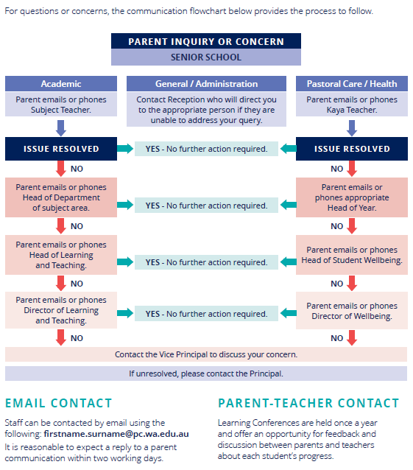

JUNIOR SCHOOL COMMUNICATION PROCESS

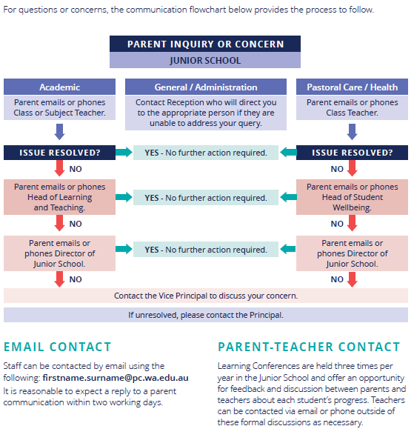

BOARDING COMMUNICATION PROCESS

